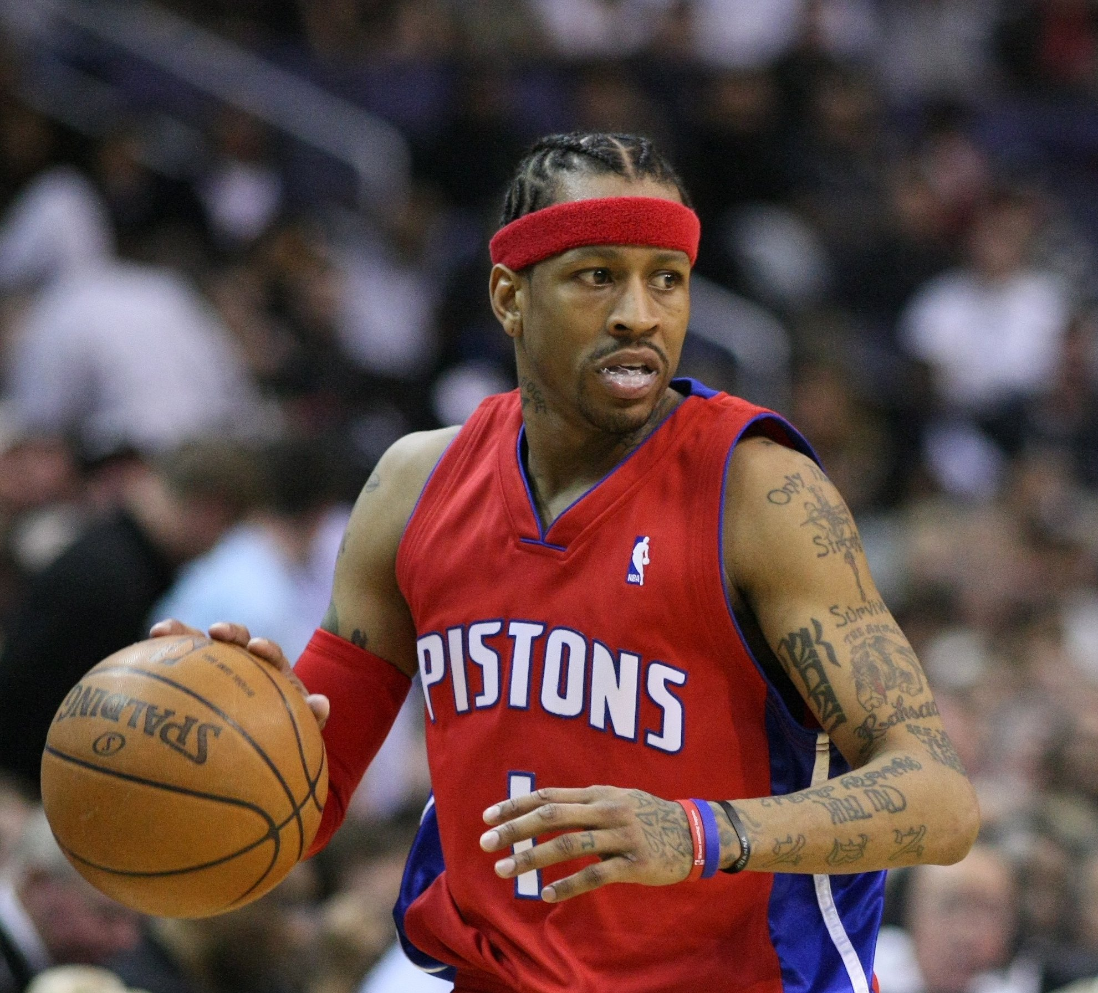

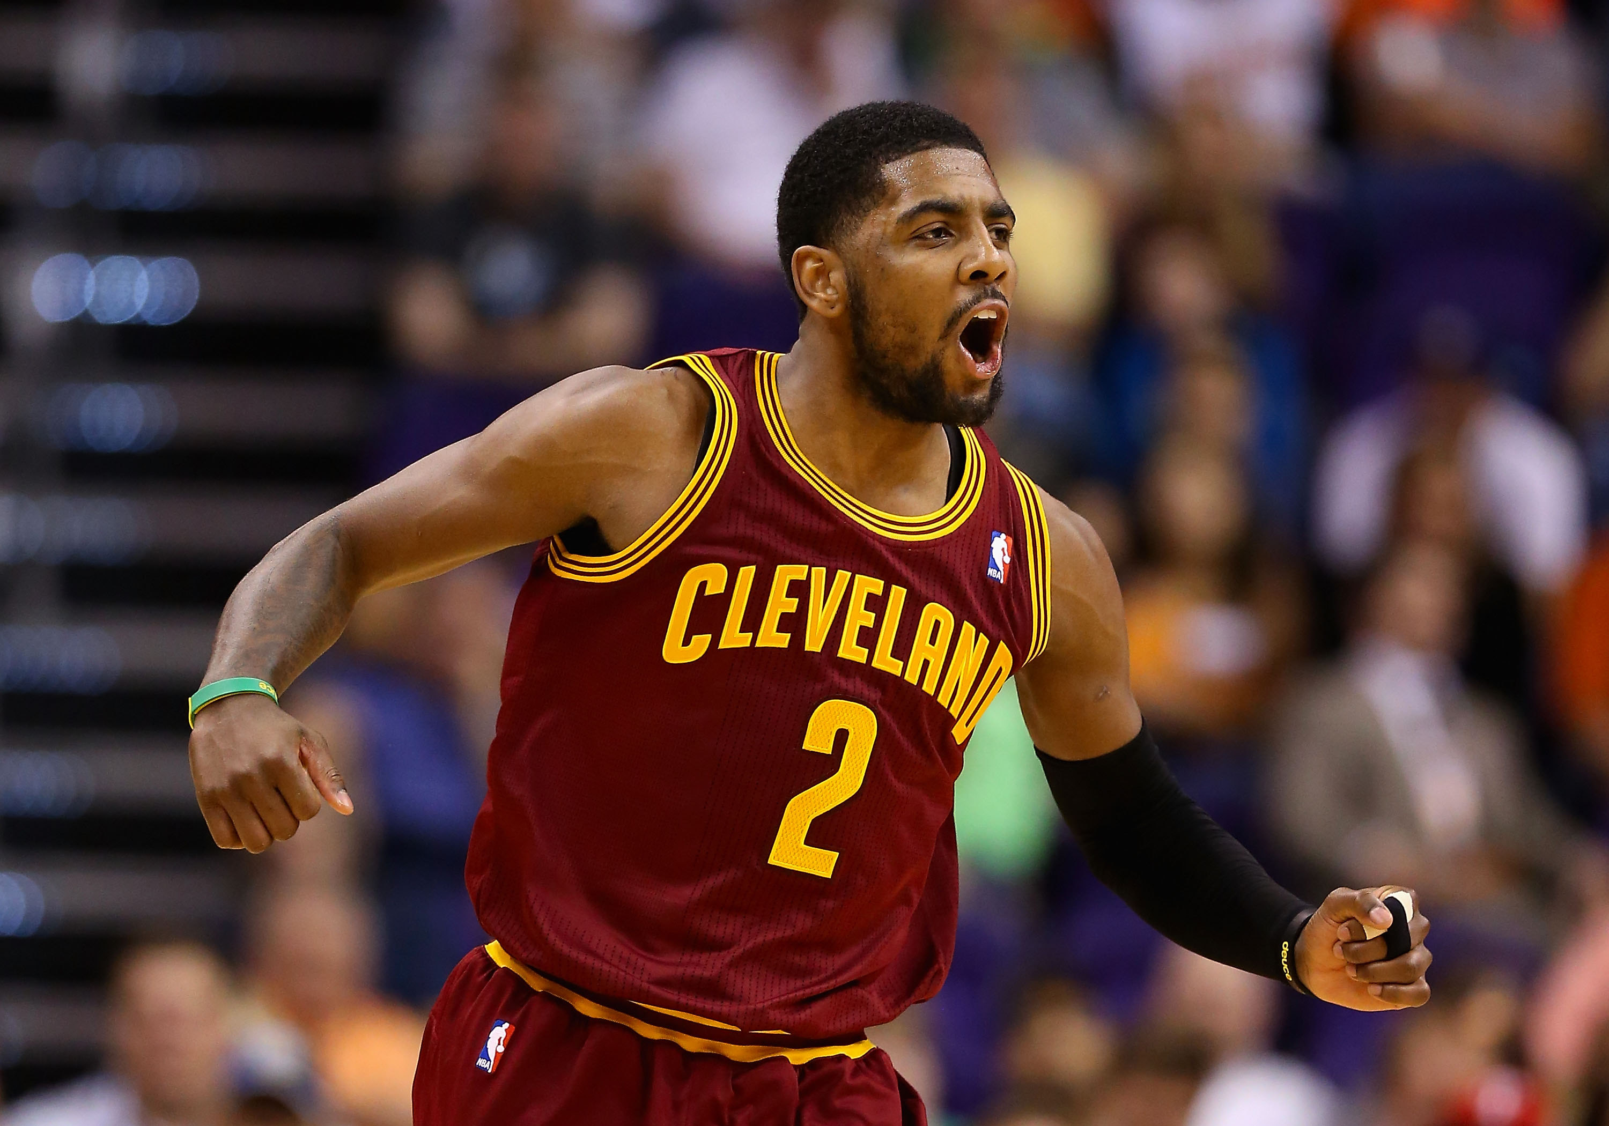

**COME OUT AND SUPPORt the california, WE WIN!**

**Our first game is October 14, 2015 At Long beach Convention and Entertainment Center**

**We Win vs. Bucks**