









This brochure is about my career business choice, in graphic design

# What is graphic design?

**Company Name**

11595 King Rd, Roswell, GA 30075

September 15, 2015

Mrs.Kennedy 2nd Period

#### What’s this about

ReJon Barksdale

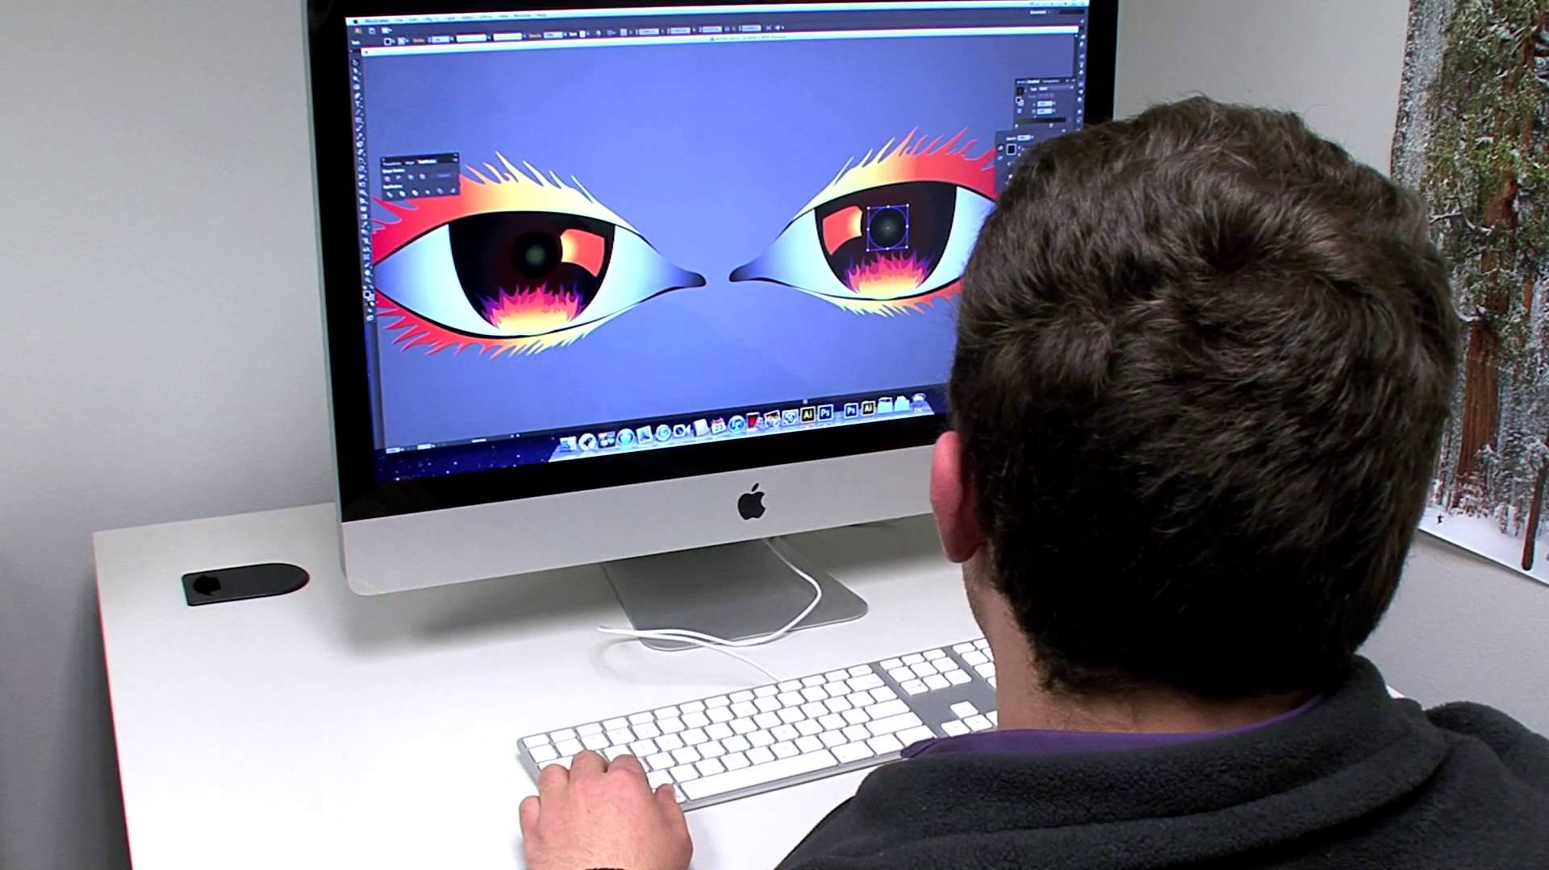

**Job outlook**

The job outlook is predicted to grow 7%. These results are expected to be put in play through 2012-2022. This is slower than the average for all occupations. Computer graphic designers are expected to face strong competition.

**Training**

There are several colleges that major in graphic computer design. When training for this certain colleges may train different. But here is some training that you will need: visualizing design and game engineering and how to animate. Those are some of the main things you will be trained for.

**Employment**

To be hired for a graphic design job you will need a bachelor’s degree in art/graphic design. If you have that you can be hired for big companies such as Nike, Adidas, and Under Armor. For Computer design you will need the same thing. There are jobs such as designing computer programs for companies such as apple.

**Working conditions**

To work in graphic and computer design there are work conditions. Such as: Determine the message being put across Meet clients and decide what the project is on, and review design and seek out errors. The most important thing is the message being put across. Either you advertise it as children or adults, even both sometimes.

**Earnings**

The annual salary of a computer graphic designer is $49,690. The median salary is $44,010 per year. That can also be said as $21.16 per hour.



#### Graphic and computer graphic design

**Nature of work**

The career I will be talking about is graphic design. This has to do with enhancing your skills in design, even art. Therefore you can make graphic t-shirt or even design video games. It all depends on what fields you want go in, their computer graphic skills.

Above is computer design